CODE OF WAGES, 2019
Code of Wages, also known as the Wage Code, was passed in August 2019. The Act consolidates the provisions of four labour laws concerning wage and bonus payments and makes universal the provisions for minimum wages and timely payment of wages for all workers in India. The Acts which are consolidated through the Code of Wages, 2019 are:
- Payment of Wages Act, 1936,
- Minimum Wages Act, 1948,
- Payment of Bonus Act, 1965 and
- Equal Remuneration Act, 1976.

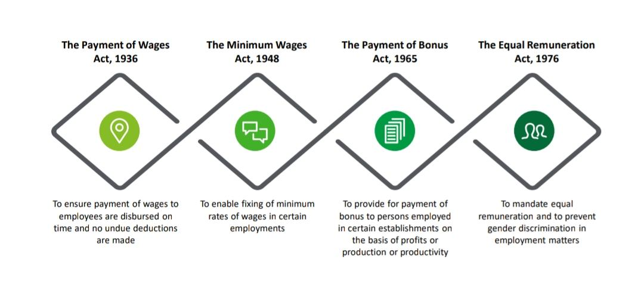

The Code of Wages applies to all the establishments irrespective of the number of employees working in the establishment. This code applies to all the employees employed in both the organized and the unorganized sector. However, the requirement of 20 or more employees in an accounting year has been provided in the code for the application of Chapter IV of the code governing the payment of bonus to employees. The Wage Code applies to all categories of employees irrespective of any ceiling limit for the payment of wages to the employees.

Overview

Amalgamate, Simplify and Rationalize the provisions of the subsumed legislations

Applies to all establishments, employees and employers as defined unless specifically exempt in the code

Spread over nine chapters with 69 sections – as against 115 sections of the earlier four legislations

Definitions provided in Chapter I – applicable across the code

Chapters II to IV covers Minimum Wage, Payment of Wages and Payment of Bonus Provisions of Equal Remuneration are contained in four sections of the first chapter

Specific provisions for Payment of Dues, Claim and Audit, Inspector cum Facilitator, Offences and Penalties,
Miscellaneous provisions etc.

Key Definitions
EMPLOYEE

Means a person who employs whether directly or through any person or on his behalf or on behalf of any person, one or more employees in his establishment, and includes occupier and manager in case of a factory. In case of any other establishment, the person who has ultimate control over the affairs of the establishment, a manager or managing director who has been entrusted with the affairs. Also includes a Contractor and Legal Representative of the deceased employer
EMPLOYER

Any person other than an apprentice employed on wages by the establishment to do any skilled, semi-skilled, unskilled, manual, operational, supervisory, managerial, administrative, technical or clerical work for hire or reward, whether the terms of employment are express or implied and also includes a person declared to be an employee by the appropriate government, does not include any member of the Armed Forces
ESTABLISHMENT

Means any place where any industry, trade, business, manufacture or occupation is carried on and includes Government establishment
WORKER

Any person other than an apprentice employed in any industry to do any manual, unskilled, skilled, technical, operational clerical or supervisory work for hire or reward whether the terms of employees be express or implied. Also includes working journalists and sales promotion
employees
CONTRACTOR

Means a person who undertakes to produce a given result for the establishment, other than a mere supply of goods or articles of manufacture to such establishment, through contract labour or supplies contract labour for any work of the establishment as mere human resource and includes a sub-contractor

Highlights of The Code and Major Compliances There under
Prohibition of Discrimination on The Ground of Gender
The Code on Wages, 2019, states that there shall be no discrimination in an establishment or any unit thereof among employees on the ground of gender in matters relating to wages by the same employer, in respect of the same work or work of a similar nature done by any employee
No employer shall, in order, pay equal remuneration:
- reduce the rate of wages of any employee; and
- Make any discrimination on the ground of sex while recruiting any employee for the same work or work of similar nature and in the conditions of employment, except where the employment of women in such work is prohibited or restricted by or under any law for the time being in force.
Where there is any dispute as to whether a work is of the same or similar nature, the dispute shall be decided by such authority as may be notified by the appropriate Government.

Minimum Wages
- No employer shall pay any employee wages less than the minimum rate of wages notified by the appropriate Government.

- An employee, who works for less than a normal working day, shall be entitled to receive full wages, except where an employee fails to work due to his unwillingness and in such other circumstances as prescribed.

- Where an employee does two or more classes of work to each of which a different minimum rate of wages is applicable, the employer shall pay not less than the minimum wage rate for each class of work, proportionate to the time involved.

- The overtime wage rate has been fixed at twice the normal rate of wages for hours worked in excess of the normal working hours.

Payment of Wages
- All wages shall be paid in current coin or currency notes or by cheque or by crediting the wages in the bank account of the employee or by the electronic mode; except for certain specified establishments, wages shall be paid only by cheque or by crediting the wages in his bank account.

- No wage period in respect of any employee shall be more than a month.

- The employer shall comply with the following time limits for payment of wages for respective wage periods:
- On a daily basis, at the end of the shift;
- On a weekly basis, on the last working day of the week, i.e. before the weekly holiday;
- On a fortnightly basis, before the end of the second day after the end of the fortnight;
- On a monthly basis, before the expiry of the seventh day of the succeeding month.
- Where an employee has been—
    - removed or dismissed from service; or
    - retrenched or has resigned from service, or
    - unemployed due to the closure of the establishment,
The wages payable to him shall be paid within two working days of his removal, dismissal, retrenchment or, as the case may be, his resignation.

Deductions from Wages
- The employer shall not make any deductions from the wages of an employee except those as are authorized under the code.

- The total amount of deductions in any wage period shall not exceed 50% of such wages; otherwise, the excess deductions may be recovered in such manner as may be prescribed.

- All such deductions and all realizations thereof shall be recorded in a register that may be prescribed.

Imposition of fines on the employee
- The employer, with the previous approval of the appropriate government/ prescribed authority, shall exhibit on the premises of the employment a notice specifying the acts and omissions for which a fine may be imposed on any employee.

- The total amount of fine which may be imposed in any one wage period on any employee shall not exceed an amount equal to 3% of the wages payable to him in respect of that wage period.

- No fine shall be imposed on any employee who is under the age of 15 years.

- No fine imposed on any employee shall be recovered from him by instalment or after the expiry of 90 days from the day on which it was imposed.

- All fines and all realizations thereof shall be recorded in a register as may be prescribed, and all such realizations shall be applied only for the welfare of persons employed as approved by the prescribed authority.

Payment of Bonus
- An annual bonus shall be paid to employees of the establishments in which 20 or more persons are employed or were employed on any day during an accounting year, drawing wages not exceeding the notified threshold and who have put in at least 30 days of work in an accounting year.

- In cases where the wage of an employee exceeds the notified threshold, the bonus payable shall be calculated as if his wage were such amount, so determined by the appropriate Government or the minimum wage fixed by the appropriate Government, whichever is higher.

- The amount of minimum bonus has been fixed at the rate of 8.33% of the wages earned by the employee or Rs. 100, whichever is higher, whether or not the employer has any allocable surplus during the previous accounting year.

- The bonus shall be paid by crediting it in the bank account of the employee within a period of 8 months from the close of the accounting year.

Records, Returns and Notices
- Every employer shall maintain a register containing the details with regard to persons employed, muster roll, wages and such other details in such manner as may be prescribed.

- Every employer shall display a notice at a prominent place of the establishment containing the abstract of this code, category-wise wage rates of employees, wage period, day or date and time of payment of wages, and the name and address of the Inspector-cum-Facilitator having jurisdiction.

- Every employer shall issue wage slips to the employees in such manner as may be prescribed.

- The above provisions shall not apply in respect of the employer to the extent he employs not more than five persons for agriculture or domestic purpose.
Provisions relating to equal remuneration
The Wages Code prohibits discrimination ‘on the grounds of gender, thus making it gender-neutral, allowing a third category of gender, i.e. transgender, to also be protected from discrimination in matters of payment of wages, recruitment and conditions of employment.

Floor Wages
The Central Government shall fix the floor wage taking into account the minimum living standards of a worker and geographical areas. Where existing minimum wages are higher than the floor wages, the same shall be retained.
The minimum rates of wages fixed by the appropriate Government shall not be less than the floor wage. The appropriate Government shall review or revise minimum rates of wages at an interval not exceeding five years.
The minimum wages shall be revised by the appropriate Government in consultation with the Advisory Board constituted in accordance with the code.

Inspector-cum-Facilitator
With the intent to remove arbitrariness and malpractices in inspection, the appropriate Government may, by notification, appoint Inspector-cum-Facilitators, who shall have the dual responsibility of advising employers and workers relating to compliance with the provisions of this code and also inspecting the establishments as assigned to them.
The code also provides for an Inspection Scheme introducing a web-based inspection and calling of information relating to the inspection under this code electronically.

Penalties on Offences:
The code provides for varying penalties depending on the nature of the offence, with the maximum penalty being imprisonment for three months along with a fine of up to one lakh rupees.

Compounding of Offences
The offence not being an offence punishable with imprisonment only or with imprisonment and also with fine has been made compoundable under the code. Such offences may be compounded by a notified Gazetted Officer for a sum of 50% of the maximum fine provided for such offence in the manner as may be prescribed

CONCLUSION
With its broad-based applicability and uniform definition of wages, the code surely promotes the aim of ease of doing business under the “Make in India” policy of the Government of India. The code has made it easier for employers to understand and thereby comply with the provisions of law.

